# Kanban – Estimates

The prebuilt *Kanban – Estimates* provides an overview of registered estimates in your NetSuite account, with each Kanban column representing an estimate status. The last column contains two Kanban columns, stacked on top of each other, one representing estimates won this month and the other one estimates lost this month.

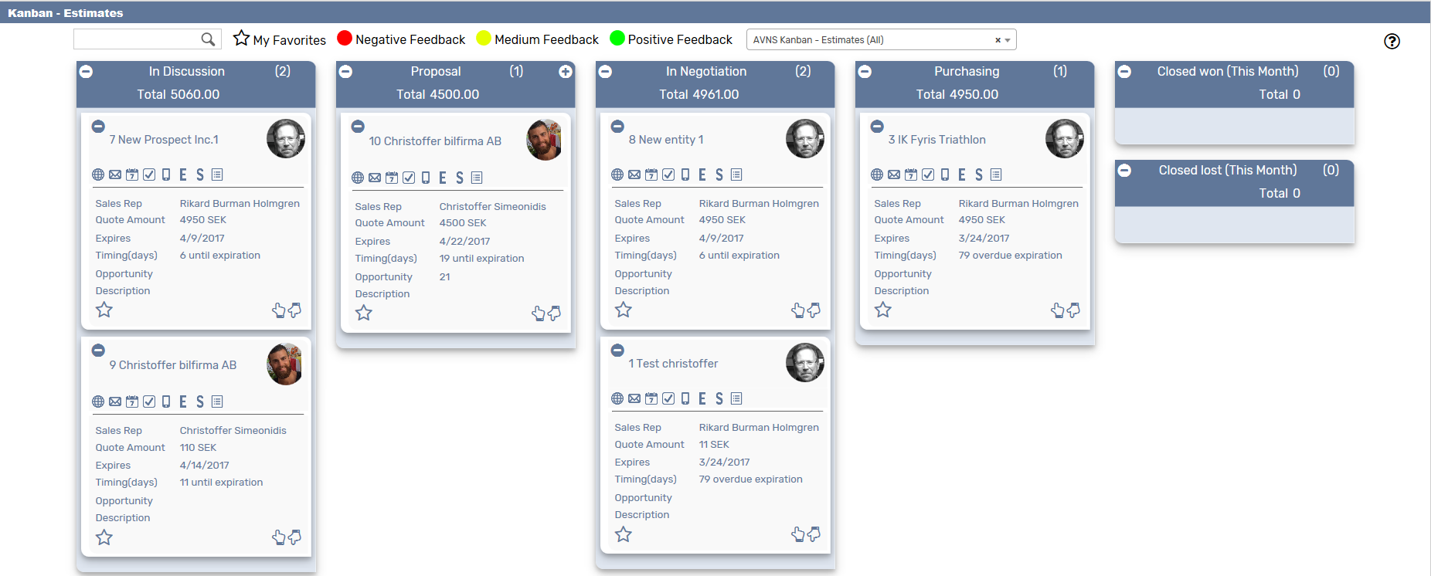

### Kanban – Estimates: Prerequisites

Before using the *Kanban – Estimates* board, please make sure the prerequisites listed below are fulfilled in order for the board to function as expected.

1. **Customer Status**  
   Since the columns of the prebuilt *Kanban – Estimates* board are based on NetSuite standard Customer status, it is important that the statuses presented in the board are available in your NetSuite account.   
     
   Navigate to Setup 🡪 Sales 🡪 Customer Statuses (Administrator) to find the list of Customer Statuses available in your NetSuite account. Compare the list from your NetSuite account with the Customer Status list which the prebuilt *Kanban – Estimates* board is based on (picture below).   
     
   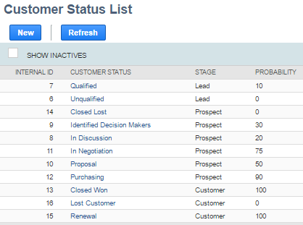  
     
   If the Customer Statuses differ between your NetSuite account and the picture above, you will need to edit the settings of the Kanban Columns for the *Kanban – Estimates* board.  
   ***Please refer to the section ‘Kanban Columns’ in the ‘Kanban User Guide’***
2. **Sales Rep & Sales Rep Image**  
   Make sure to mark the checkbox ‘Sales Rep’ on the Employee record for all available Sales Reps.   
   If an image has been uploaded to the *Image* field on the Employee record, this image will be displayed on the Kanban card. If no image is available, a predefined profile icon will be displayed instead.

### 

### Kanban – Estimates: Card Moves & Column Actions

The *Kanban – Estimates* board contains five Kanban Columns. Each column has been configured with one or several Column Actions. Double clicking on any card in the *Kanban – Estimates* board will open the estimate record in edit mode.  


1. **In Discussion**
   1. *Card Moves* – Kanban cards in the column *In Discussion* can be moved to all other columns in the Kanban board, except *Closed Won (This Month)*.
   2. *Column Actions* – when moving a Kanban card to the column *In Discussion* the status of the record represented in the Kanban card will be updated to *Estimate* – *In Discussion.*
2. **Proposal**
   1. *Card Moves* – Kanban cards in the column *Proposal* can be moved to all other columns in the Kanban board, except *Closed Won (This Month)*.
   2. *Column Actions* – when moving a Kanban card to the column *Proposal* the status of the record represented in the Kanban card will be updated to *Estimate - Proposal*
3. **In Negotiation**
   1. *Card Moves* – Kanban cards in the column *In Negotiation* can be moved to all other columns in the Kanban board, except *Closed Won (This Month)*.
   2. *Column Actions* – when moving a Kanban card to the column *In Negotiation* the status of the record represented in the Kanban card will be updated to *Estimate – In Negotiation*.
4. **Purchasing**
   1. *Card Moves* – Kanban cards in the column *Purchasing* can be moved to all other columns in the Kanban board, except *Closed Won (This Month)*.
   2. *Column Actions* – when moving a Kanban card to the column *purchasing* the status of the record represented in the Kanban card will be updated to *Estimate – Purchasing*.
5. **Closed Won (This Month)**
   1. *Card Moves* – Kanban cards in the column *Closed Won (This Month)* can be moved to all other columns in the Kanban board. To move card here a Sales Order needs to be created.
   2. *Column Actions* – when moving a Kanban card to the column *Closed Won (This Month)* the status of the record represented in the Kanban card will be updated to *Closed Won*.
6. **Closed Lost (This Month)**
   1. *Card Moves* – Kanban cards in the column *Closed Lost (This Month)* can be moved to all other columns in the Kanban board, except Closed Won (This month).
   2. *Column Actions* – when moving a Kanban card to the column *Closed Lost (This Month)* the status of the record represented in the Kanban card will be updated to *Closed* *Lost.*

### Kanban – Estimates: Available Card Actions

The Kanban cards in the *Kanban – Estimates* board each contains eight Card Actions.

1. 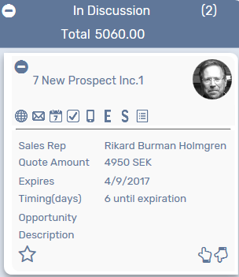**Show Customer 360**

Run the customer 360 report.

1. **New Email**Add a new email.
2. **New Event**

Add a new event.

1. **New Task**Add a new task.
2. **New Phone Call**Add a new phone call.
3. **Copy Estimate**

Copy existing estimate.

1. **New Sales Order**Create a sales order from the estimate.
2. **Show Activity**Show a list of all activities related to the estimate.

### Kanban – Estimate: Alternative Searches

There are three alternative searches for the *Kanban – Estimate* board.  
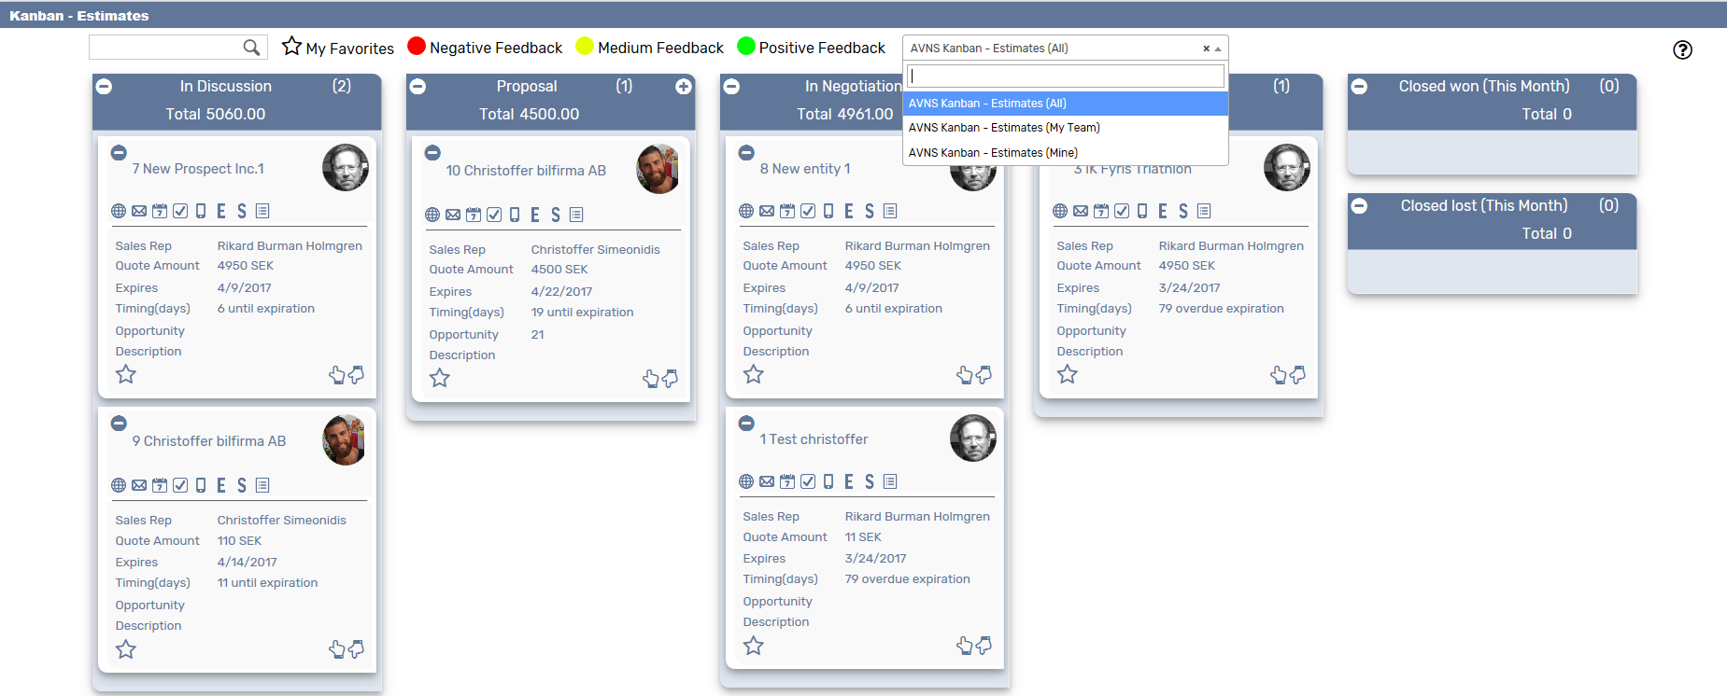

1. **AVNS Kanban Estimate**Display all estimates.
2. **AVNS Kanban Prospect – My Team**Display estimates with sales rep any of my team.
3. **AVNS Kanban Prospect - Mine**Display estimates with you as a sales rep.

### Kanban – Estimates: Available Colors

There are three colors available for the *Kanban – Estimates* board, which can be used to highlight and filter the Kanban cards (Negative / Medium / Positive feedback). These are defined in the *Color* subtab of the Kanban configuration record. 